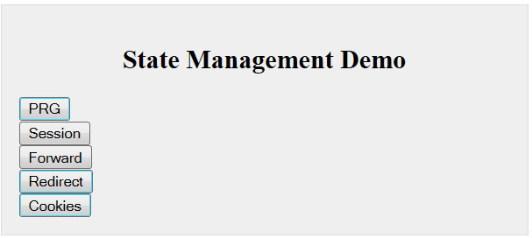

The title - “State Management Demo” is the application attribute SET in the configuration file

**PRG Button** – Demonstates POST-REDIRECT-GET Pattern. Uses Product form as example. There is a PRG “flag” on the

form to determine whether or not to do FlashAttributes/PRG Pattern on POST. Best run in a “real” browser. Try

page refresh & back-arrow on browser to see the effect.

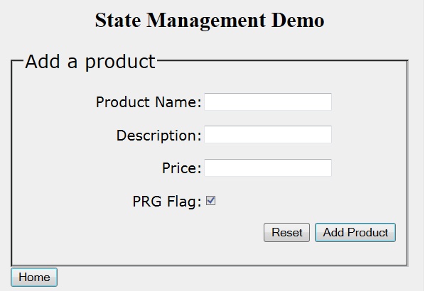

**Session Button** – Demonstrates @SessionAttributes. Uses a “dummy” form. Upon Form submit, it does a

status.setComplete to remove the @SessonAttributes. On the form page, there is also a

“Delegate Session Controller” button. This exercises @SessionAttributes shared between controllers.

Each time a Controller method is invoked, the values of three session attributes[Leonardo, Splinter, Donatello]]

are displayed on the console. The @SessionAttribute value[ the value in the Controller model] is displayed as

well as the actual “real” session value stored in the session object [HttpSession].

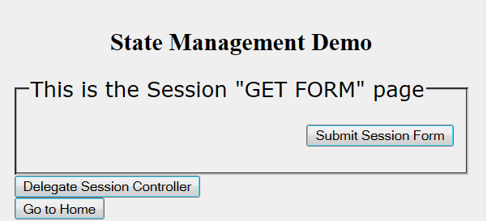

**Forward Button** – Demonstrates server side “continuity” of request attributes [ both objects & primitives]

**Redirect Button** – Demonstrates loss of request attributes that are objects on “roundtrip”. Also demonstrates how

request attributes that are String/primitives are automatically appended as request parameters to the

target URL.

**Cookies Button** – Demonstrates the use of Cookies for state management

Use MS Explorer*** - as FF SAVES sessionID if you have the “save all your tabs” feature enabled

NOTE: disable cache [through interceptor] for “neutralizing” back button… on browser [see xml config]